**CCDR Kyrgyz: analysis 8-12-2024**

**Methods**

Four production systems were analyzed: cattle household systems (representing 50% of the cattle herd), cattle individual farm systems (representing the other 50%), and sheep and goat systems. The baseline data for the household cattle and small ruminant systems was derived from an analysis conducted for the Kyrgyz NDC 2021, while the baseline data for individual farming systems was drawn from a similar cattle production system used in the analysis for the CCDR Uzbekistan.

**Business As Usual (BAU) Scenario**: Using FAOstat population data, linear projections from 2010 to 2022 showed a 100.6% growth in cattle and a decline of -70.5% in goats by 2050. Differences in growth rates were assumed between the two cattle production systems: household farms were projected to make up 60% of the herd by 2050, with individual farms accounting for the remaining 40%. Sheep exhibited a stabilization trend, therefore a shorter linear projection from 2017 to 2022 was used, indicating a growth rate of 1.5% by 2050.

**Resilience Scenario**: The resilience scenario projections were based on the IFAD RRPCP program, which served as a reference for improvements in herd and feed management. Given that the program concludes in 2025, it was assumed that the new management practices would be fully adopted by 2050. Herd production assumptions were multiplied by 2 for household cattle and small ruminants, and by 2.5 for individual farm production (excluding mortality rates and months of age at first partition, which were already optimized). Additionally, a 20% increase in the live weight of small ruminants was assumed. Lastly, a herd reduction of 0.5% was projected, as outlined in the Nationally Determined Contribution (NDC), resulting in a total herd reduction of 13% by 2050.

### Climate Adaptation Scenario:

In the climate adaptation scenario, it was assumed that protein stability would be maintained similar to the BAU scenario. Furthermore, we replace 10% of the beef production with broiler meat. These strategies allowed for a 27.5% reduction in the cattle herd by 2050.

|  |  |  |
| --- | --- | --- |
| current growth | Reform growth | Climate adaptation |
| * Linear projections from 2010 to 2022 for cattle and goat * Linear projections from 2017 to 2022 for sheep | * projections were based on IFAD RRPCP * practices in program fully adopted in 2050 * assumptions multiplied by 2 for household cattle and small ruminants (except for mortality and months of age at first partition) * assumptions multiplied by 2.5 for individual farm production (except for mortality and months of age at first partition) * 20% increased liveweight of small ruminants * herd reduction of 0.5% per year | * 10% increase in broiler production * 27.5% reduction for cattle * Adjusted production due to heat resilience breeds tbd * Move to zero-grazing with introduction methane additives? * Biodigesters are mentioned in NDC…. But we do not have the data |

**Results:**

|  |  |  |  |  |  |  |  |  |
| --- | --- | --- | --- | --- | --- | --- | --- | --- |
|  | total GHG emissions (mil tCO2-eq/year) | CH4 emissoins (mil tCH4) | Meat production in carcass weight (mil kg/year) | Total milk production(mil t/year) | Herd size | | | |
|  | number of cattle | number of small ruminants | number of broiler |
| ref (2022) | 5.8 | 0.16 | 154.9 | 1.97 | 1,649,617.30 | 6,748,748.44 | 0 |
| maintained growth (2050) | 9.3 | 0.26 | 229.2 | 3.85 | 3,008,747.18 | 5,980,033.35 | 0 |
| reform growth (2050) | 10.4 | 0.28 | 328.5 | 4.94 | 2,468,662.17 | 5,991,969.04 | 0 |
| climate-resilient growth (2050) | 8.1 | 0.22 | 297.3 | 3.58 | 1,785,062.78 | 5,991,969.04 | 4,098,139.78 |

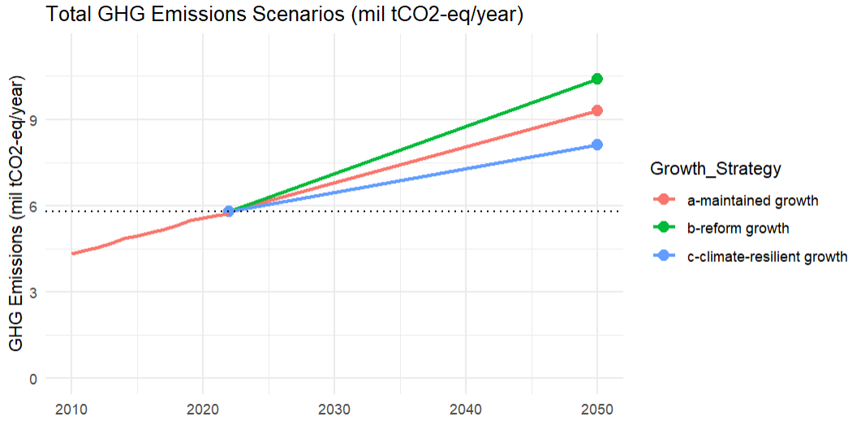

**Figure 1.1: Greenhouse Gas Emissions Projections livestock sector for Kyrgyzstan Republic (2022-2050)**  
- Historical Data from FAOstat – Tier 1 Direct Emissions (2010-2022)

**To discuss:**

* **Check baseline data with experts**
* **Check the assumptions with the experts? = finalize narrative and if the corresponding values make sense.**
* **Tier-1 is it logical that the line is the same**